SECURITY DEPARTMENT
FORMER HEADS OF DEPARTMENTS

Mr. Wilfred Wahome
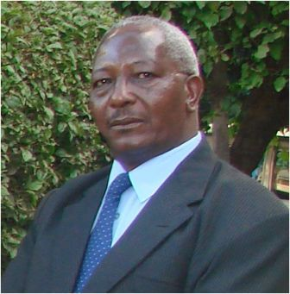
Mr. Wilfred Wahome was the Director, Security & Safety Services from 2001 to 2019.
During his tenure, the department was elevated to a directorate from a department. He digitalized security systems by installing CCTV system in various buildings in the University, as well as digital radio communication. He ensured that security officers were regularly trained to keep up with emerging crime trends. He ensured that security officers were adequately kitted and their morale boosted. It is during his time that the University outsourced security services to adequately cover the whole university due to a shortage in the number of security personnel after retrenchment.

Mr. Anthony Gacheru

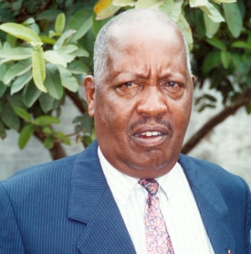

Mr. Anthony Gacheru was the Chief Security Officer from 1995 to 2001.
He ensured that professionalism and discipline was maintained in the security department. However, it was during his time that security personnel were retrenched greatly impacting the provision of security services to the institution.

Mr. Charles Mungai
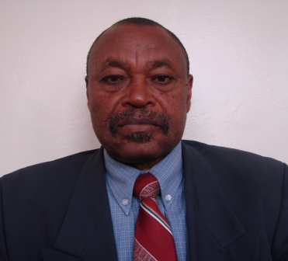
Mr. Charles Nguri Mungai was the Chief Security Officer from October 1987 to February 1995.
He oversaw the employment of over 500 security personnel to man different campuses within the University. He ensured that staff were adequately kitted and motivated to perform their work.

Mr. Peter Sila

Mr. Peter Sila was the Chief Security Officer from 1985 to 1987.
He was the first Chief security officer after the department was created out of Estates department. He oversaw the employment of security personnel to man the campuses due to increase in security incidents.

